Sheridan Dela Cruz
April 4, 2026
Module 2.2

FlowChart
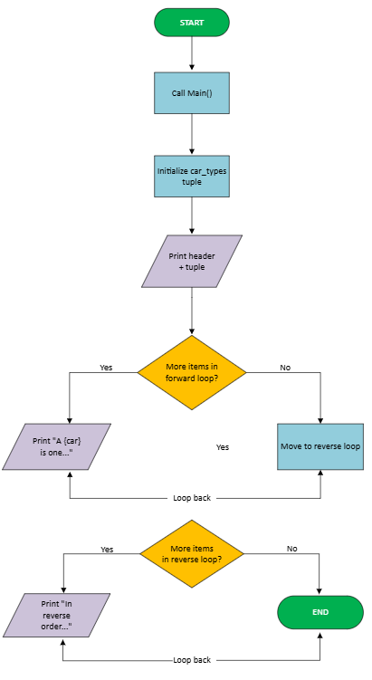

Screenshot 1- Debugger paused at breakpoint
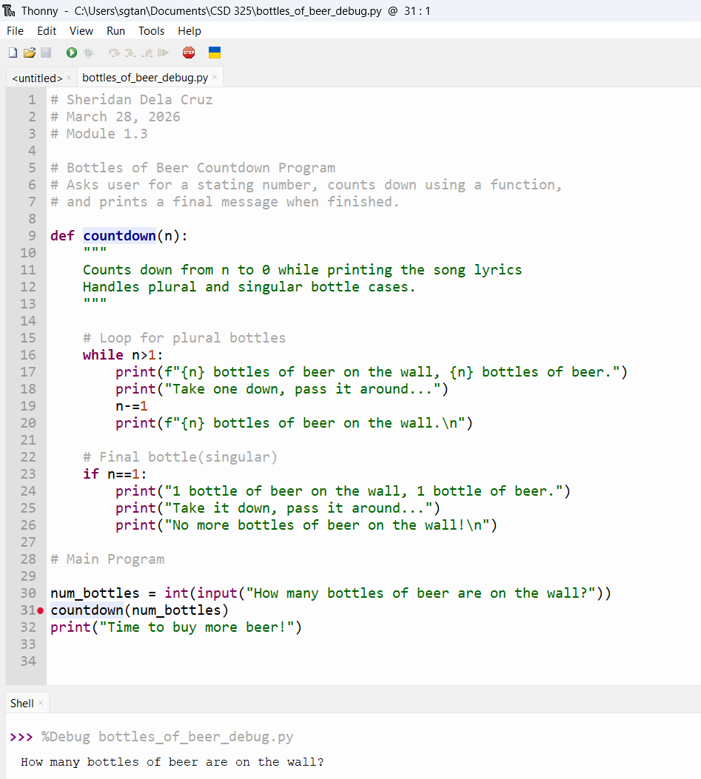

Screenshot 2-Stepped into the function
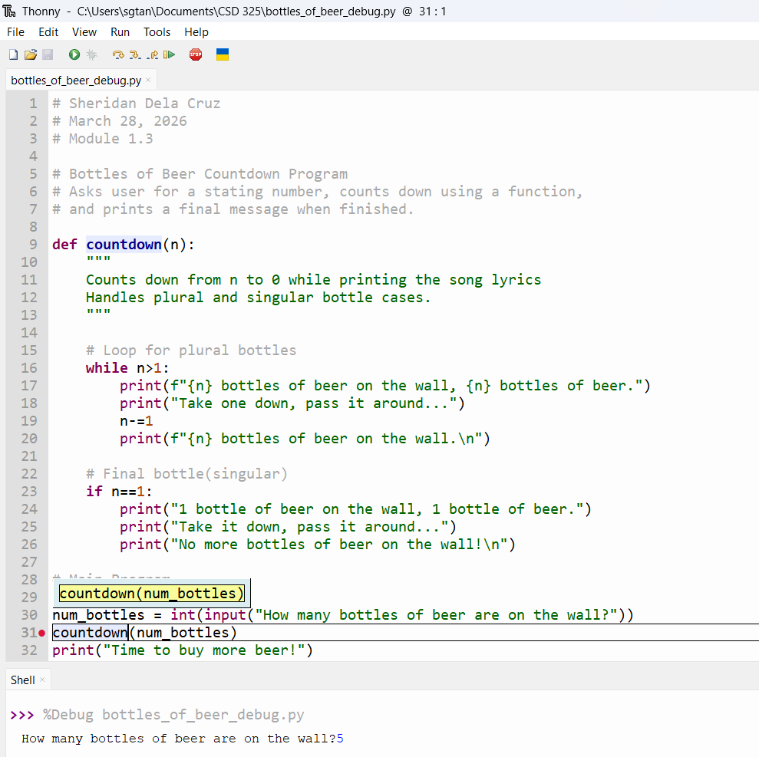

Screenshot 3- NameError triggered for debugging demonstration.
